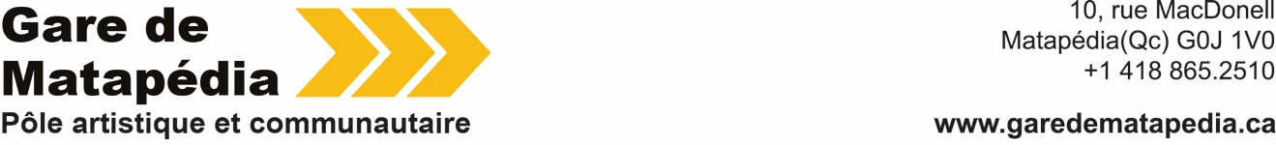

Press Release
For immediate release

Master of Fine Arts Students from NSCAD University
take over Gare de Matapédia

Public presentation in the form of an
open afternoon workshop

Matapedia, Monday, February 3, 2025 - La Gare de Matapédia - Pôle artistique et communautaire, is delighted to welcome 23 students from the Master of Fine Arts program at NSCAD University in Halifax, Nova Scotia, and their teacher and artist Craig Leonard, for an in situ creation session. The public is invited to come and meet the artists and discover their in situ creations from Wednesday February 5 to Sunday February 9, 2-6pm.

- These encounters are convivial and open moments between the public and the artists.
- Discussions with the artists will take place mainly in English, with translation available on site. Access is free and accessible to all.
- Coffee and tea service available

This activity, initiated by Craig Leonard, is a way of putting these young artists to the test, in the form of impromptu creations, in a context where they have to draw inspiration on site. The students, Bianca McDonald, Devon Pennick-Reilly, Echo Ji, Forbes Sang, Ginger Yu Yu, Gracia Isabel Gómez Cantoya, Hana Steincamp, Janelle Ledua, Jenny Shi, Katherine Diemert, Liam MacAloney, Nadine Sures, Nour El Sabeh, Quinn O’Connor, Sarah Young, Shay Donovan, Yue Li, Yuting Song, Arielle Twist, Arjun Lal, Vanessa Iafolla, Autumn Star and Janelle Ledua, will create specific, spontaneous works. They use a wide variety of media, including sculpture in ice, metal and found elements; photography using light-sensitive paper and phytograms; sound using hydrophone; drawings based on natural elements collected during walks; and experimental and narrative film.

ABOUT HALIFAX SCHOOL OF FINE ARTS, NSCAD UNIVERSITY

NSCAD University is located in historic downtown Halifax, Nova Scotia. The school's alumni are among Canada's most renowned artists. The dynamic between faculty and students encourages innovative dialogue and collaboration. The University's Master of Fine Arts program is an intensive, full-time studio program that recognizes and considers a range of diverse and innovative practices, and offers students the opportunity to develop their work in a context of intense, interdisciplinary critical discussion.

ABOUT OPEN ACCESS RESIDENCIES

In response to the growing demand for artistic mobility, Gare de Matapédia - Pôle artistique et communautaire is continuing its Open Access Residency program, offering its studio space at the station free of charge. A call for applications is open at all times to artists and curators from all horizons, to offer tailor-made residencies in the inspiring setting of a magnificent natural setting and a heritage train station dating from 1903.

ABOUT GARE DE MATAPÉDIA

La Gare de Matapédia - Pôle artistique et communautaire is both a new space dedicated to contemporary art and a meeting place for the community. Developed by Quartier Éphémère organization, it offers a cross-residency program, exhibition spaces and cultural mediation activities for schools, community groups and citizens. A variety of activities are regularly scheduled, including meetings with artists, art workshops and guided tours.

– 30 —

MORE INFORMATIONS
Caroline Andrieux
Cheffe de projet
418 865 2510
caroline@garedematapedia.ca

